Name ______Christopher Holmes____________________________________

Read the article on "Data Structures for Databases".

Do questions #1, 4, 9, 13, 14, 18, and 19 at the end of the article.

***#1 Define a flat file. Give an example (other than one in this text) of a flat file and an example of a file that is not flat.***

-A flat file is a file that contains no repeating groups. An example of a flat file would be an excel file. An example of a non flat file would be a student information system database file.

***#4 Show how inverted lists (indexes) can be used to maintain the file in Review Question G.1 in two different orders simultaneously.***

***#9 Define a simple network and give an example structure(other than one in this text).***

-A simple network is a collection of records and the 1:N relations among them.

-An example would be where an agent manages clients and represents entertainers. The clients make payments and schedule bookings of the entertainers that perform and play musical styles.

***#13 Define complex network. Offer an example of a complex network structure (other than one in this text).***

-A complex network is a collection of records and relationships, but the relationships are many-to-many instead of one-to-many.

-An example of a complex network would be a network of me, my family, and colleagues, and some of our likes, dislikes, jobs, and hobies.

***#14 Give an occurrence of the complex network in Review Question G.13.***

-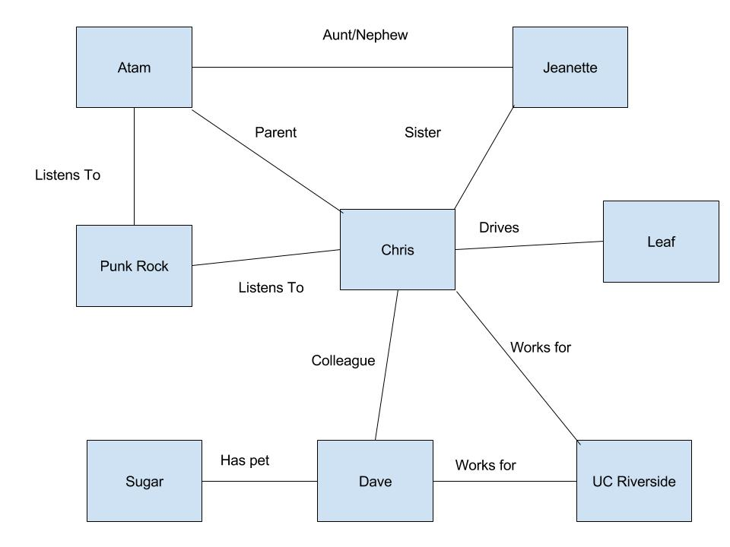

***#18 Give an example of a file containing a unique secondary key (other than one in this text). Represent an occurrence of that file using an index on the secondary key.***

-A file that would contain a unique secondary key would be a student record in a student information system. This record would have the student id number, that would then be indexed to provide the access needed to access the other records that would be related.

***#19 Define a nonunique secondary key for the file in Review Question G.18. Represent an occurrence of that file using a linked list on the secondary key.***

-A nonunique secondary key would be the individual section numbers that each student is taking.